TALLER DE REPASO SCIENCE – Eight Grade
Usa este taller para repasar, pero no lo mandes ya que no es un taller calificado.

Tema 1 – Atomic Theory
Visit the following links
https://www.proprofs.com/quiz-school/quizshow.php?title=atomic-theory_1&q=5
https://www.learningliftoff.com/high-school-science-learning-activity-mass-number-practice/
Answer the following questions? Justify
- If Atom #1 has 19 protons and 22 neutrons, and Atom #2 has 20 protons and 22 neutrons, are these isotopes of the same element?
- Draw the nucleus of these two atoms.
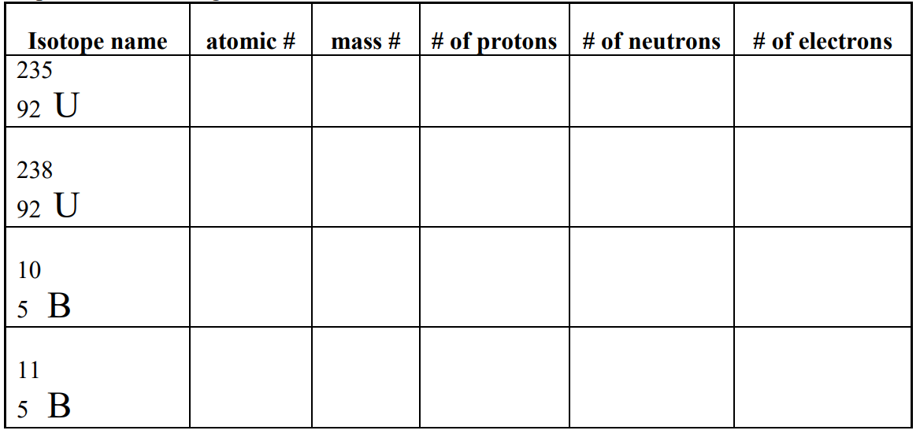

Tema 2 – Average Atomic Mass
Calculate the following average atomic masses:
https://quizizz.com/join/quiz/5ea47764da8ab7001b8ca3e7/start?referrer=5e811b1da008db001b8ae05c

Tema 3 – Molar Mass
Calculate the following molar masses:
1) LiI
2) PbCO₄
3) Mg(OH)₂
4) K₃PO₄
5) C₆H₁₂O₆
6) Na₃P
7) AgF
8) NH₄C₂H₃O₂
Answers:
1) 133.8 g/mol
2) 283.2 g/mol
3) 58.32 g/mol
4) 212.3 g/mol
7) 399.9 g/mol
8) 99.94 g/mol
9) 126.9 g/mol
10) 77.08 g/mol

