
NUEVO COLEGIO DEL PRADO
Science 8th Grade
Guía de Trabajo Semana 1, Marzo 30 – Abril 3
Email: jmunoz@nuevocolegiodelprado.edu.co
Topic: Atomic Theory
- Take a look at the different atomic models. Use the PDF named “Atomic Models”
Answer the following questions on your notebook:
- Why was Aristotle wrong about his theory?
- What is the law of conservation of mass? If you have 1 Kg of Maracuyá, 1 Kg of Water and 0,3 Kg of Sugar; and then prepare Juice, what would be the mass of this heterogeneous mixture? Does law of conservation of mass work in this example?
- Thompson mentioned that atoms are balanced in charge. How is this model called? What subatomic particle did he discover?
- Ernest Rutheford found out that some particles bounced when they hit the atom. What did he discover?
- In a few words describe the experiments: Cathode ray tube and Rutherford .
- What’s the formula to determine an atom mass?
- What new information was added by Bohr’s atomic model?

- Print or obtain a Periodic Table, you can use the one on the blog.
Analyze the relation between atomic number and atomic mass.
Check symbols for the elements. What information can you determine from the names and symbols?
- Atoms are formed by:
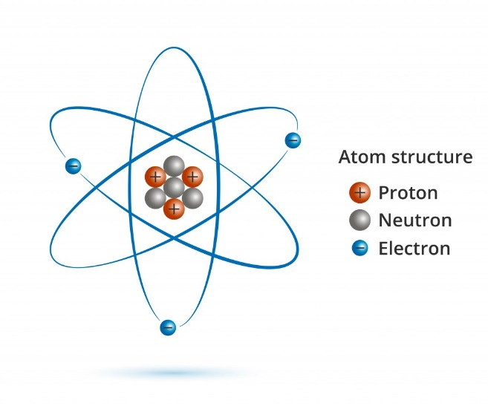
However, this picture of an atom is proved to be wrong. Investigate about Schrodinger Atomic Model and Justify the differences between the two atomic models.

https://www.youtube.com/watch?v=1StzvGFX4_c
https://www.youtube.com/watch?v=NSAgLvKOPLQ

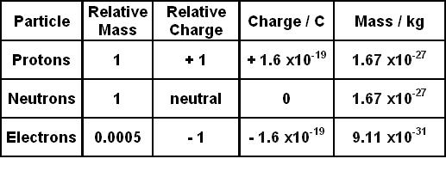
- Calculations:
According to this table the mass of the atom is made up most by PROTONS and NEUTRONS. Electron’s mass is almost 0.
We use the relative mass to calculate the mass of the atoms. Use the formula for Atomic Mass.

Examples:
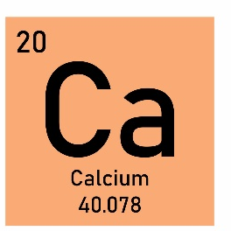
Calcium atomic number in the periodic table is: 20
That 20 as atomic number means that calcium has 20 protons. It also means that neutral calcium has 20 electrons.
For a neutral atom the atomic number always corresponds to protons and electrons.
Coincidentally calcium normally possesses 20 neutrons.

Using the formula: A = Z + n A = 20+ 20 = 40

In the periodic table we find that Calcium atomic mass is about 40 amu. (atomic mass units)
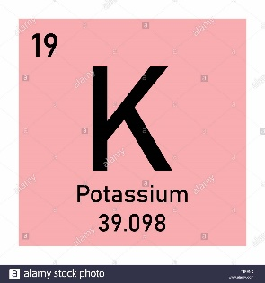
Potassium has 19 protons and 19 electrons. (see that the atomic number is 19)
Potassium also has 20 Neutrons. (Neutrons amount vary!)

Using the formula: A = Z + n A = 19 + 20 = 39

In the periodic table we find that Potassium atomic mass is about 39 amu. (atomic mass units)

What happened with the mass of electrons in both calculations? REMEMBER: electron’s mass is = 0

What is the Atomic Mass (A) of an atom that has:
a. 27 protons, 27 electrons, and 30 neutrons. ……………….. Name of the element: …………………………………….
b. 36 protons, 36 electrons, and 48 neutrons. ……………….. Name of the element: …………………………………….
C. 75 protons, 76 electrons, and 110 neutrons. ……………….. Name of the element: …………………………………….
d. 11 protons, 11 electrons, and 11 neutrons ……………….. Name of the element: …………………………………….
e. 47 protons, 48 electrons, and 60 neutrons ……………….. Name of the element: …………………………………….

